A000-MEX-Mayan-God L-226 BCE-799 CE

MASTER 1

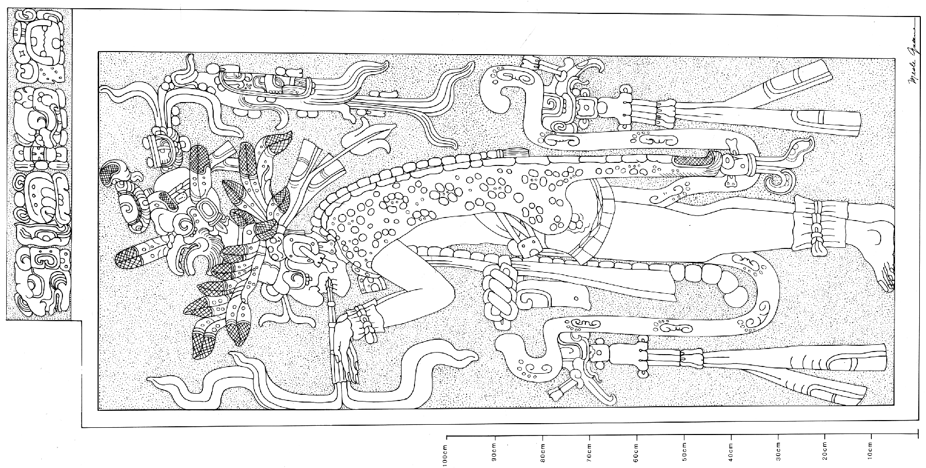 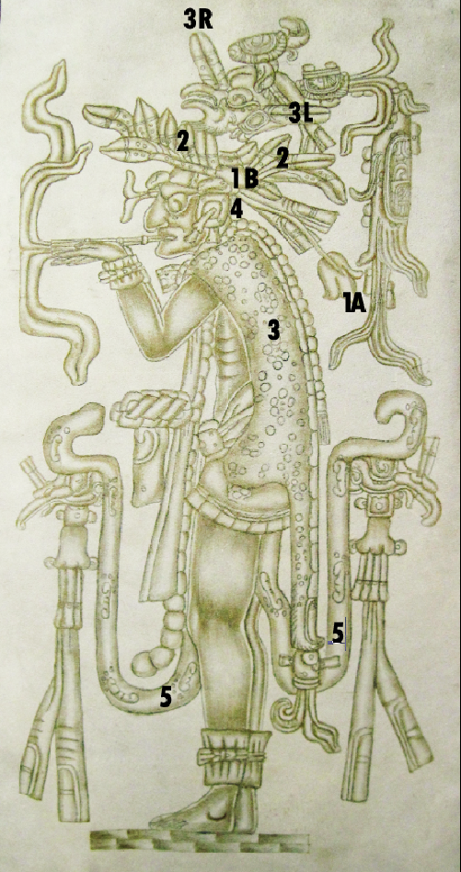

Fig. 1. Mayan-God L- Palenque, Temple of the Cross-226 BCE-799 CE

after Greene 1991, plate 43.

Fig. 2. Mayan-God L- Palenque, Temple of the Cross-226 BCE-799 CE-Atlantika Collection Reproduction.

**Case no.: 10**

**Accession Number: A….**

**Formal Label: Mex-**Mayan-God L- Palenque, Temple of the Cross-226 BCE-799 CE

**Display Description:**

This portrayal of an aged man, with sunken cheeks, toothless jaws, and thin physique is none other than God L, the powerful jaguar God of the Underworld, who is wearing a jaguar ear, a jaguar pelt complete with its tail fashioned into an elaborate cloak with attached bead-like elements down the back terminating at the waist. These bead-like elements are found on Taino figurines of Puerto Rico and Hispaniola where they denote the spinal positions at which psychotropic drugs affect the individual. God L wears an elaborate muan bird headdress of the harpy eagle (*Harpia harpyja*), with the cartouche of the number 12 on top of its head, which may signify the duration in days the portrayed psychotropic event will take. From the head of the harpy eagle two flares issue forth a large plant with an infixed, inverted Sun God wearing a death (*cimi*) sign on his cheek and a mirror in his forehead. This plant may represent an as yet unidentified plant with psychoactive substances which associates it with the death glyph as the expected feeing one may have after smoking or ingesting it.

Since this is the only Mayan monument that shows the act of smoking tobacco, probably *Nicotiana rustica*, it is fitting that the plant be given a prominent iconographic place. The flower is shown at 1A with its stem terminating at 1B with its pointed leaves.

 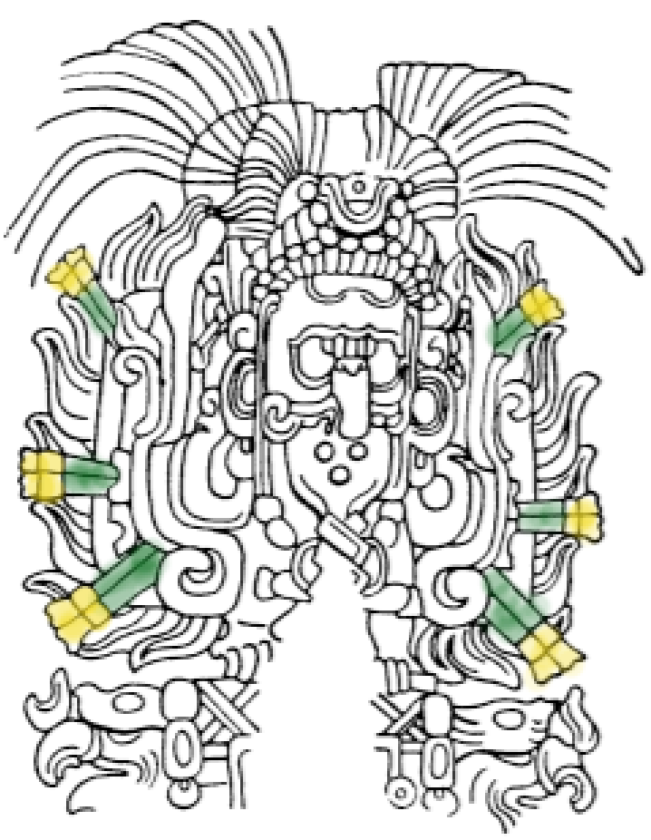 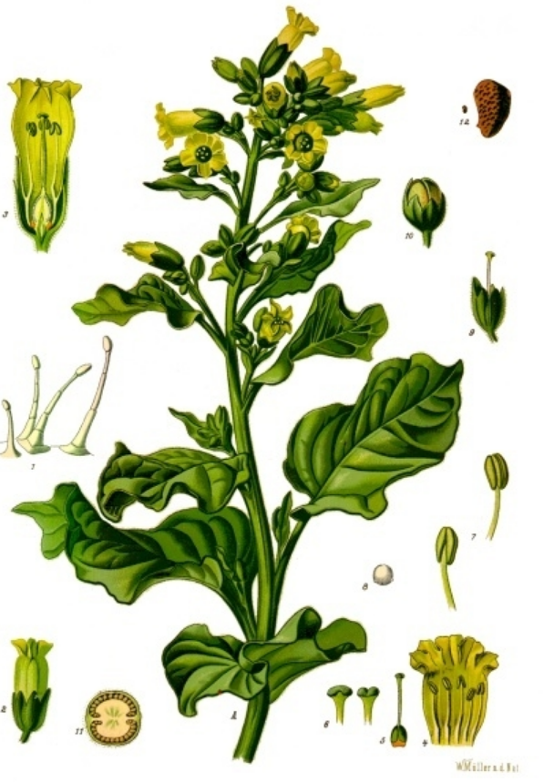

Fig. 2. Flowers of *Nicotiana rustica* (colored areas added to Thompson 1950, fig. 20, no 17, Cop. H).

Fig. 3. Flowers of *Nicotiana rustica* from Köhler 1897: Bauern-Tabak. A blühende Pflanze in natürl. Grösse; 1 Behaarung, vergrössert; 2 Blüthe, etwas vergrössert; 3 dieselbe im Längsschnitt, stärker vergrössert; 4 aufgeschnittene Krone, desgl.; 5 Stempel, desgl.; 6 oberer Theil des Griffels mit Narbe, desgl.; 7 Staubgefässe, desgl.; 8 Pollen unter Wasser, desgl.; 9 abgeblühte Blüthe, desgl.; 10 Frucht, etwas vergrössert; 11 dieselbe im Querschnitt, stärker vergrössert; 12 Same, natürl. Grösse und vergrössert.

**LC Classification:** F1435.1.P

**Date or Time Horizon:** 226 BCE-799 CE

**Geographical Area:** Palenque, Chiapas, Mexico

**Map, GPS coordinates:** [17°29′2.32″N 92°2′46.78″W](https://tools.wmflabs.org/geohack/geohack.php?pagename=Palenque&params=17_29_2.32_N_92_2_46.78_W_type:landmark)

**Cultural Affiliation:** Late Preclassic to Early Postclassic Maya civilization

**Media:** copy in gold ink on tan rawhide.

**Dimensions:**

**Weight:**

**Condition: replica**

**Provenance:** unknown

**Discussion:**

*Nicotiana rustica* is a potent tobacco species containing ca 900 percent more nicotine than common *Nicotiana tabacum* and relatively high levels of the inverse agonists, β-Carboline harmala alkaloids, which are monoamine oxidase inhibitors (MAOIs) that are also found in the vine *Banisteriopsis caapi* (ayahuasca, caapi or yagé), which is still used today in Peru and other locations in South America. These alkaloids have anxiogenic (anxiety-producing) effects and prevent the breakdown of dimethyltryptamine in the upper and lower intestines by reversibly inhibiting monoamine oxidase producing psychoactivity upon oral administration. This indicates that God L’s smoking of *Nicotiana rustica* could produce the psychoactive experience of envisioning images, as in this case of conjuring a jaguar to compliment his jaguar apparatus.

God L is also a deity of trade and has been likened to the cigar-smoking “Grandfather”(*Mam*) Maximón (a Tz'utujil deity from the region to the south of Lake Atitlán in Guatemala). *Nicotiana rustica* was probably traded directly by the Palenque nobles with the Taino of the Cuba, the nearest Taino chiefdoms in the period 226 BCE-799 CE.

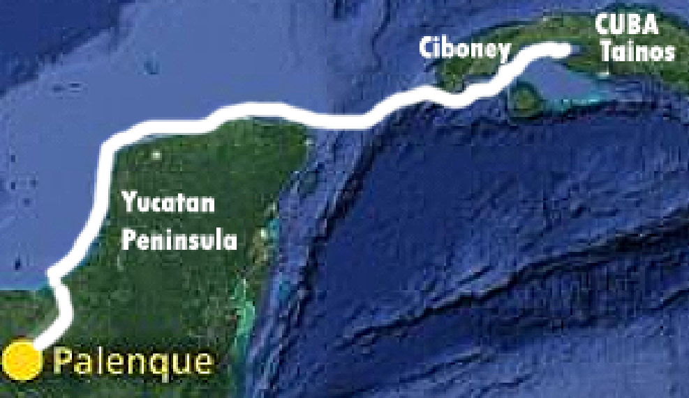

Fig. 4. Proposed trade route between Palenque and the Taino Chiefdoms of Central and Eastern Cuba. Most of the marine journey involved dead reckoning along the Yucatan and southern Cuban coasts. The blue water section was a 200 mile stretch from the tip of the Yucatan peninsula and the tip of western Cuba inhabited by the Ciboney. The first Taíno settlements were in central southern Cuba.

The Taínos inhabited the Greater Antilles (comprising Cuba, Jamaica, Hispaniola [Haiti and the Dominican Republic], and Puerto Rico) in the Caribbean Sea. They had two ways of smoking tobacco. The first way involved “*tabago,*” a Y-shaped pipe (ceramic or stone) that is inserted in the nostrils for snuffing smoke. Toasted tobacco leaves were referred to as *cohiba* (Ernst 1889), and when these leaves were wrapped they were known as “*cigars*”, like the one God L is smoking. *Nicotiana spp.* probably diffused directly to Palenque from one of the nearest Taino chiefdom in Central Cuba, since no other Mayan sites depict it being smoked before or during the reign of Kan-Bahlum, 684-702 CE, when this panel was being sculpted on the door jamb leading to the inner sanctuary of the Temple of the Cross at Palenque (see Lounsbury 1976).

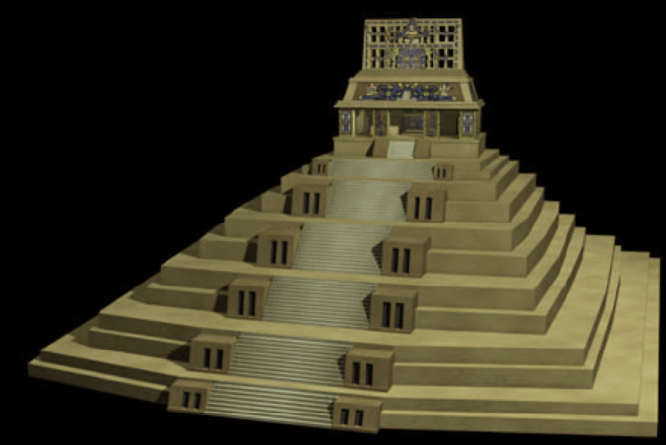

Fig. 2. Temple of the Cross, Palenque, Chiapas, Mexico. After <http://www.maya-3d.com/content//2011/07/palenque-temple_of_the_cross.jpg>. The cross motif on the apex of the temple is the Cosmic Tree, the Milky Way.

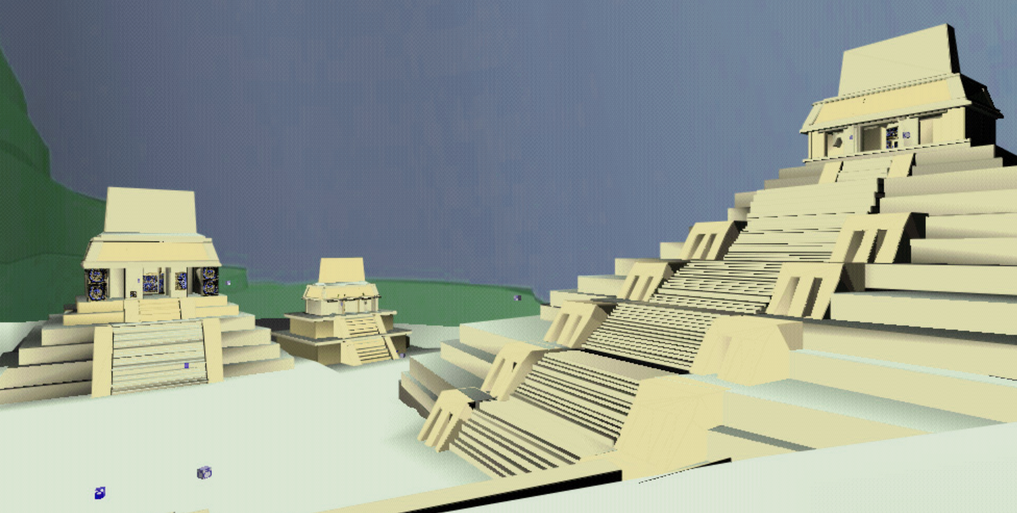

Fig. 3. Reconstruction of the Temple of the Sun (left), Temple XIV (center), and Temple of the built by Kan-Bahlum, who reigned 684-702 CE. From Mdcarrasco at English Wikipedia.

Each temple in Palenque is dedicated to a god in the Palenque triad. The king must proceed from temple to temple until he enters the Temple of the Cross (the Temple of the World Tree) where God L resides in the Underworld. Only there can the installed king recover the gift of life and prosperity for his people.

**References:**

Ernst, A. 1889. "On the etymology of the word tobacco," *The American Anthropologist* 2(2): 133–142.

Houston, Stephen. 1996. “Symbolic Sweat baths of the Maya: Architectural Meaning in the Cross Group at Palenque, Mexico,” *Latin American Antiquity*, 7(2): 132-151.

Köhler, Franz Eugen. 1887-1898. [*Köhler's Medizinal-Pflanzen in naturgetreuen Abbildungen mit kurz erläuterndem Texte. Atlas zur Pharmacopoea germanica, austriaca, belgica, danica, helvetica, hungarica, rossica, suecica, Neerlandica, British pharmacopoeia, zum Codex medicamentarius, sowie zur Pharmacopoeia of the United States of America.*](http://www.worldcat.org/title/kohlers-medizinal-pflanzen-in-naturgetreuen-abbildungen-mit-kurz-erlauterndem-texte-atlas-zur-pharmacopoea-germanica-austriaca-belgica-danica-helvetica-hungarica-rossica-suecica-neerlandica-british-pharmacopoeia-zum-codex-medicamentarius-sowie-zur-pharmacopoeia-of-the-united-states-of-america/oclc/5577154&referer=brief_results)Berlin-Lichterfelde, H. Bermühler Verlag.

Lounsbury, Floyd G. 1976. “A Rationale for the Initial Date of the Temple of the Cross at Palenque.” In *The Art, Iconography, and Dynastic History of Palenque, Part III: Proceedings of the Segunda Mesa Redonda de Palenque*, ed. Merle Greene Robertson, 211-224. Pebble Beach, CA: Robert Louis Stevenson School.

Lounsbury, Floyd G. 1980. “Some Problems in the Interpretation of the Mythological Portion of the Hieroglyphic Text of the temple of the Cross at Palenque.” In *The Third Palenque Round Table, 1978*, Part 2, ed. Merle Greene Robertson, 99-115. Palenque Round Table Series Vol. 5. Austin: University of Texas Press.

Lounsbury, Floyd G. 1985. “The Identities of the Mythological Figures in the "Cross Group" of Inscriptions at Palenque”. In *Fourth Round Table of Palenque, 1980*, vol. 6, gen. ed. Merle Greene Robertson; vol. ed., Elizabeth P. Benson, 45-58. San Francisco: Pre-Columbian Art Research Institute.

Miller, Mary. 1999. *Maya Art and Architecture*. London and New York: Thames & Hudson.

Miller, Mary; Karl Taube. 1993. *An Illustrated Dictionary of the Gods and Symbols of Ancient Mexico and the Maya*. London: Thames & Hudson.

Robertson, Merle Greene. 1990. *The Sculpture of Palenque, Volume IV. The Cross Group, the North Group, the Olvidado, and Other Pieces.* Princeton: Princeton University Press.

Thompson J. Eric S. 1950. *Maya hieroglyphic writing: introduction.* Carnegie Institution of Washington publication, 589. Washington, DC: Carnegie Institution of Washington.